1. **Go to the website below:**

<http://www.yjs.sjtu.edu.cn/ssfw/login.jsp>

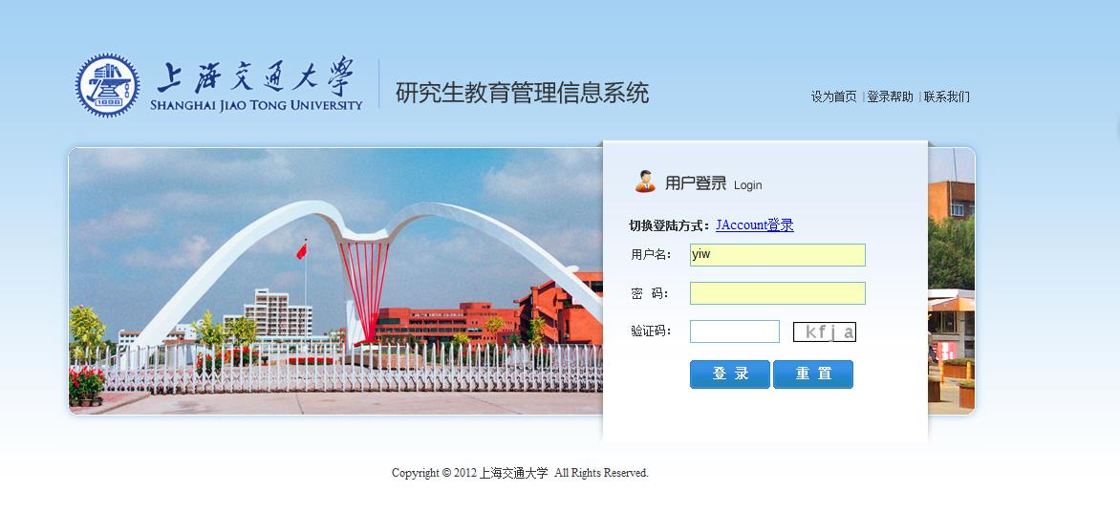

1. **Click on JAccount登陆**

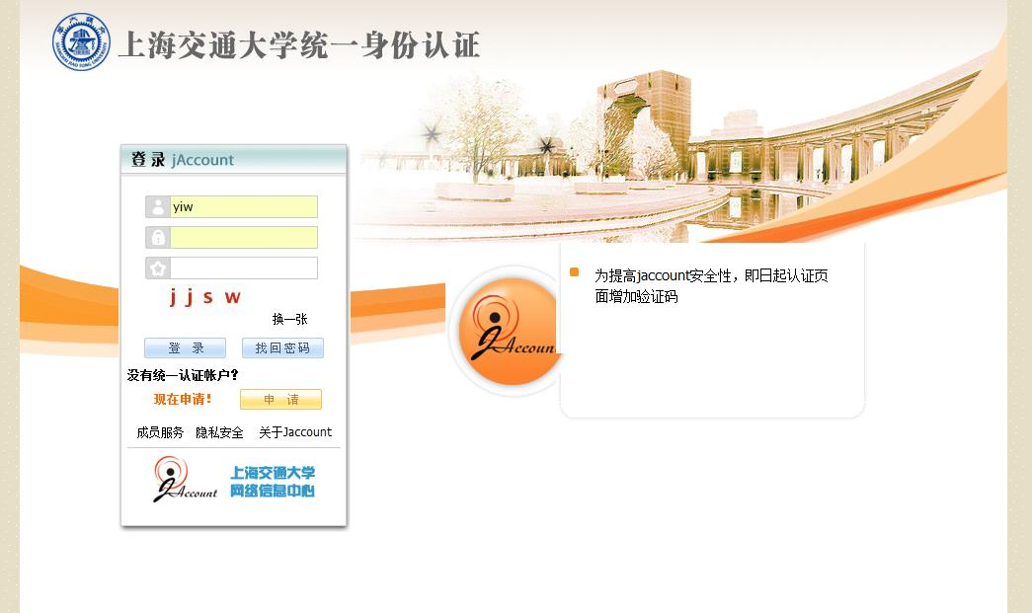

Log in with your jAccount and Password, click “登陆” to log in

1. **You will see the page as below:**

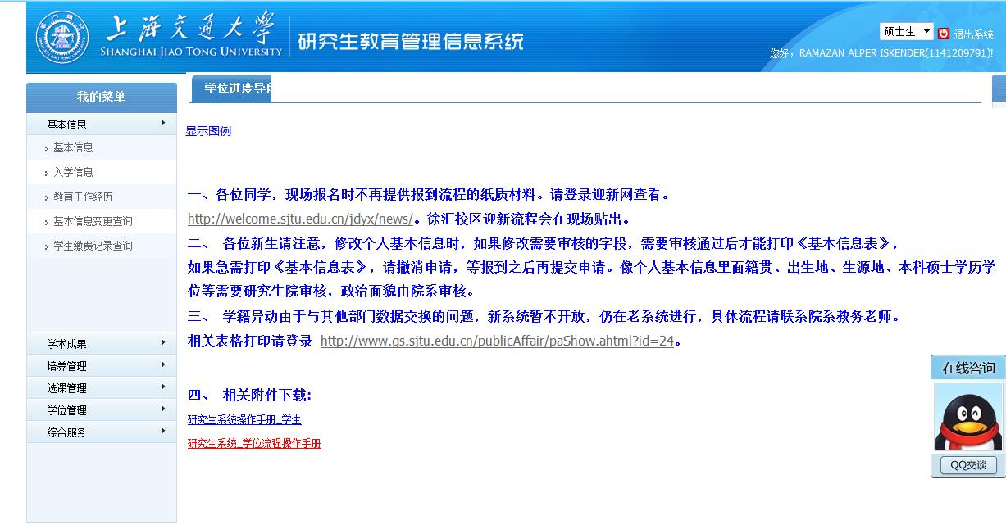

1. **Choose “培养管理”, then choose “成绩查看”**

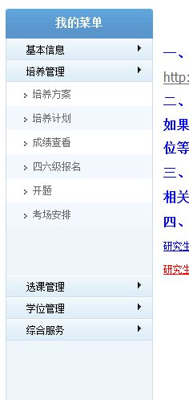

1. **Then you can see all the grades**

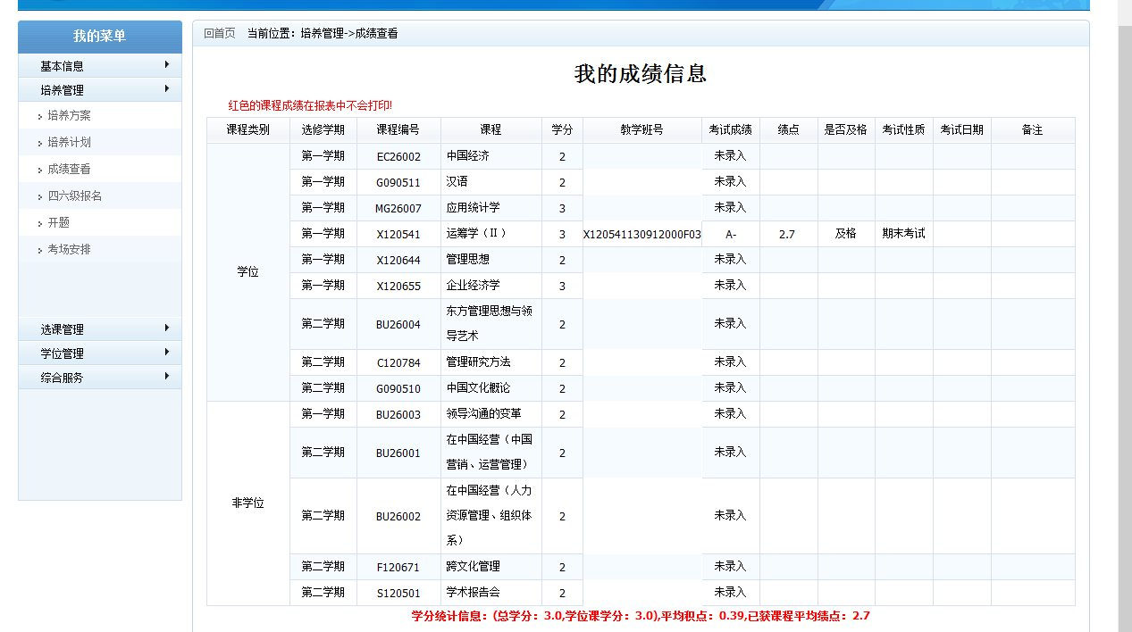

Average GPA

Course Name

Credits

Pass or not

Score

GPA

1. **Check your course schedule:**

Choose “选课管理” then “我的课表” to check your course schedule.